**My Summer Diary**

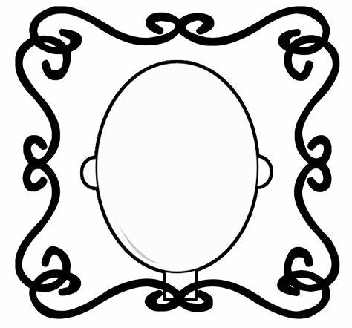

Name: __________________

**2020**

Books I read or listened to:

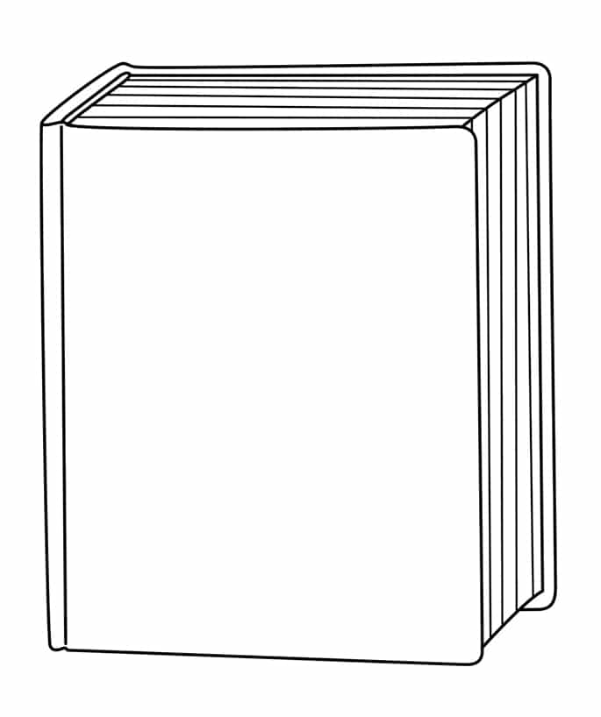

My favourite book was _______________________________________ because ________________________________________________________

_________________________________________________________________

_________________________________________________________________

_________________________________________________________________

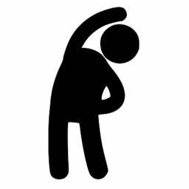

Design your own workout to keep active and healthy!

Draw pictures of the exercises you do and label them e.g. bunny hops, star jumps, squats and lunges

Keep a tally chart to show how many times you do your workout!











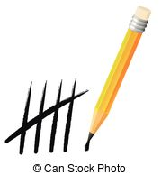

Summer Puzzles

Spot 10 differences in these pictures!

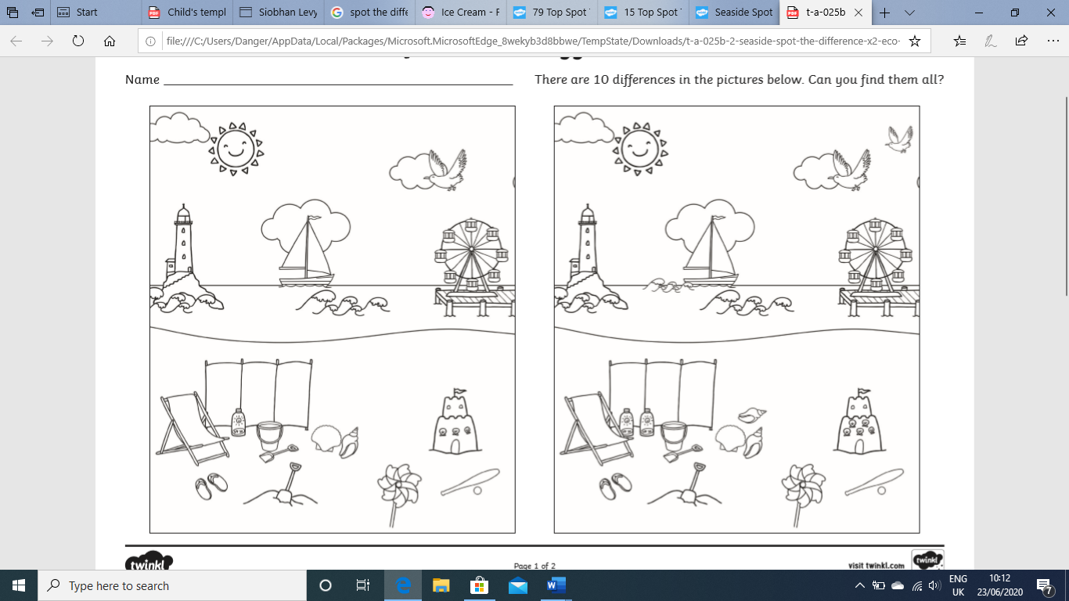

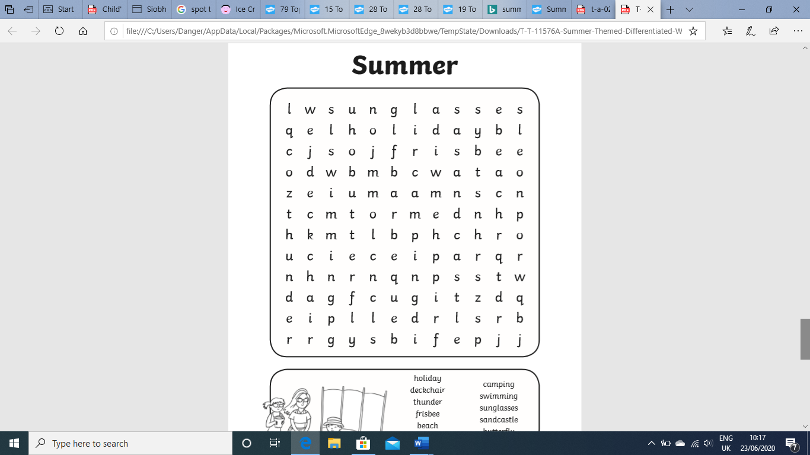

Each row and column must contain the digits 1-6

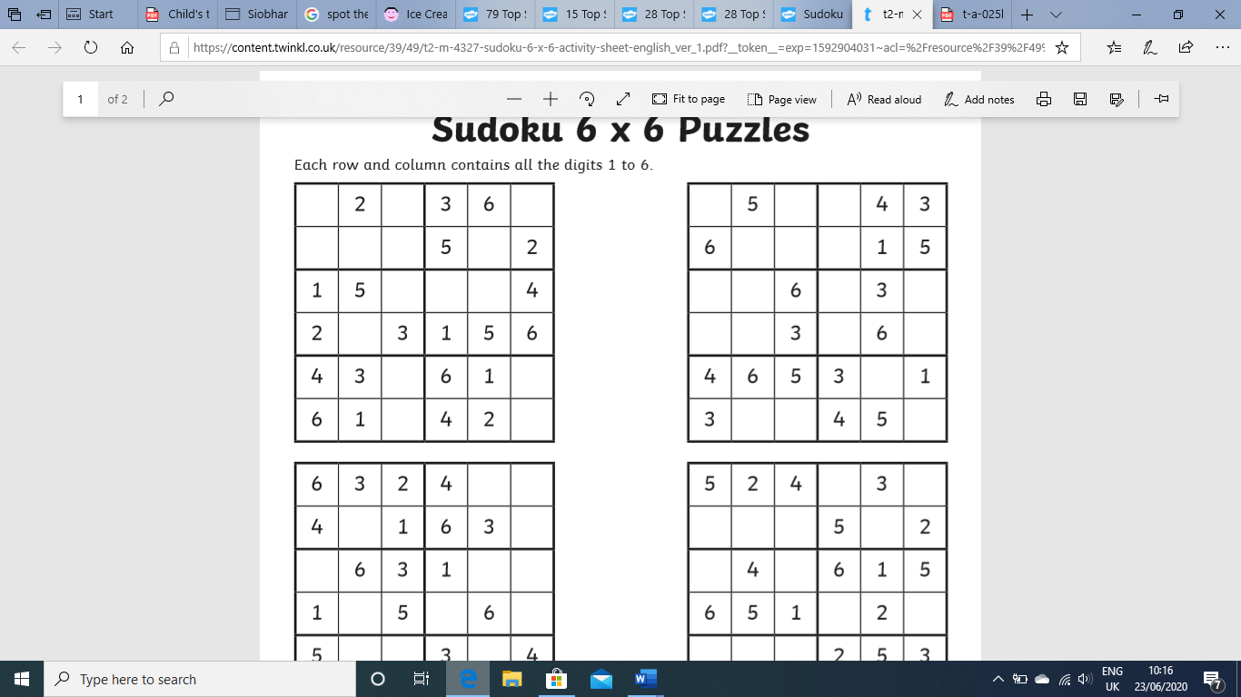

Find these words in the wordsearch!

holiday deckchair thunder frisbee beach camping

swimming sunglasses sandcastle butterfly

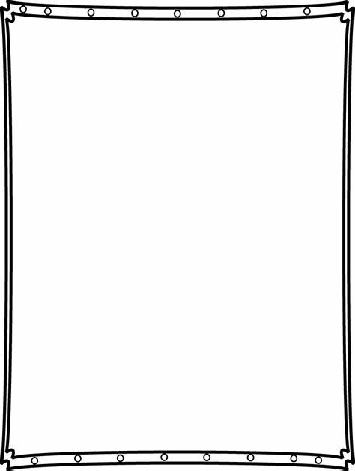

Summer Artwork

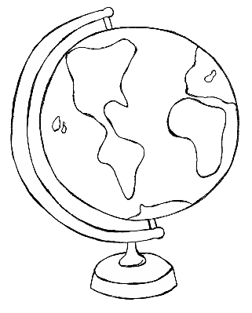

Where would you go?

My dream holiday…



How would you get there?

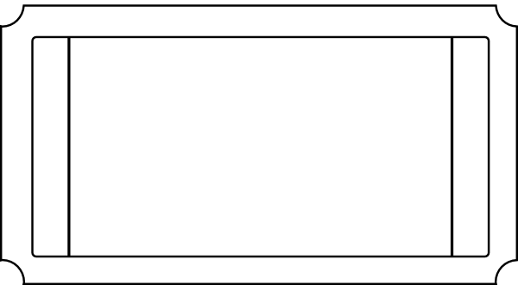

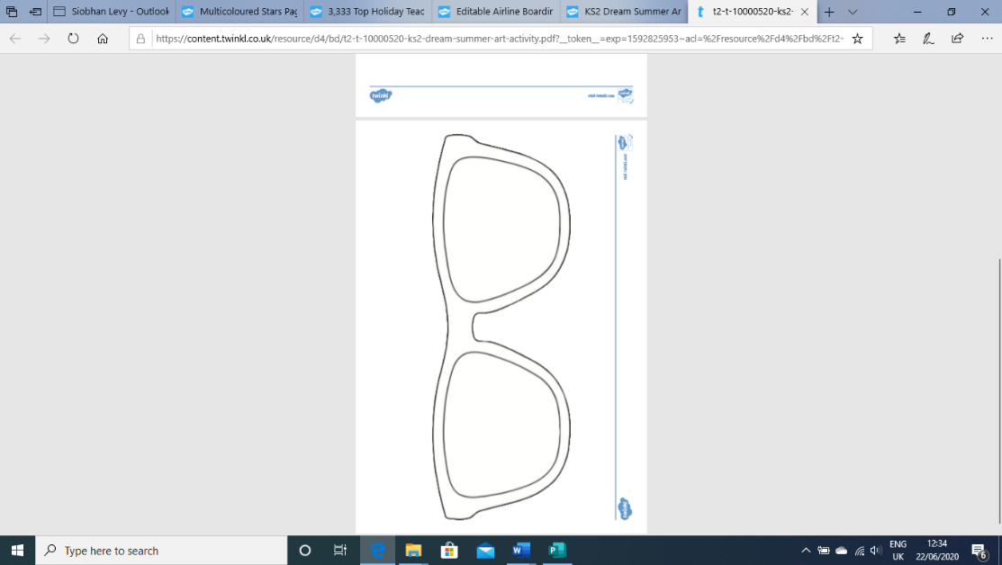[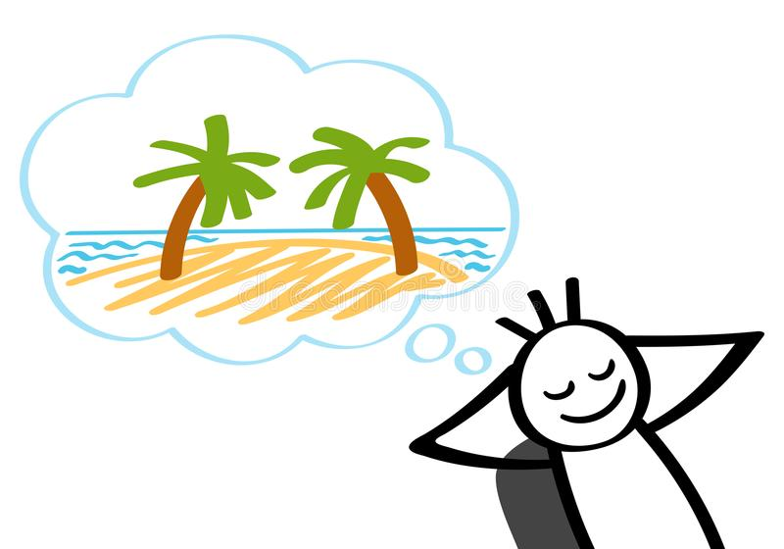](https://www.google.co.uk/url?sa=i&url=https://www.dreamstime.com/illustration/dreaming-vacation.html&psig=AOvVaw28EexeLDpkw4d40knYx5IR&ust=1592912655236000&source=images&cd=vfe&ved=0CAIQjRxqFwoTCMC1j5qsleoCFQAAAAAdAAAAABAD)

What would you do whilst you were there?

Who would you go with?

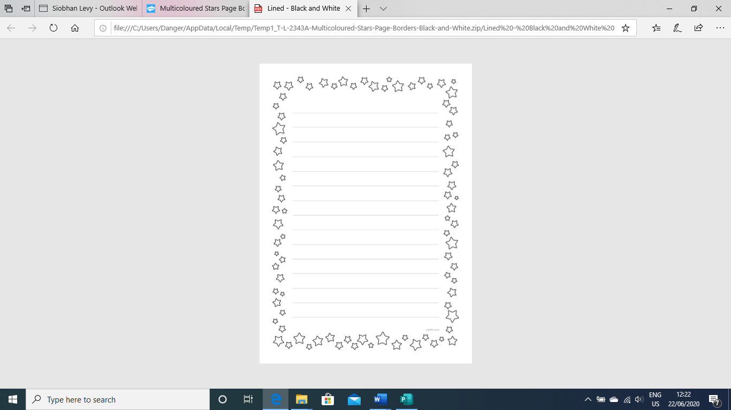

Write a letter or some questions to your new teacher!

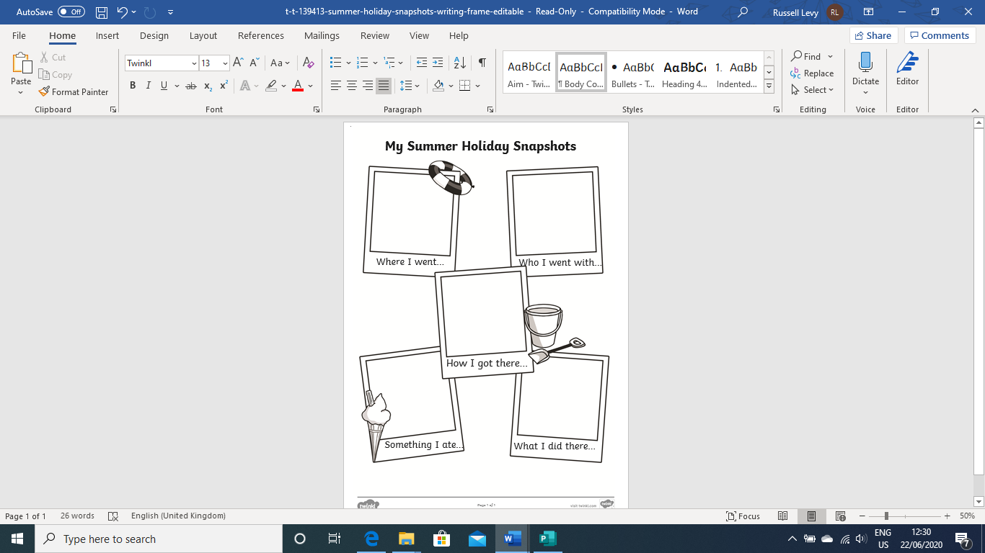

My favourite day