Lesson 1
Nouns

Let’s learn about Nouns
https://www.youtube.com/watch?v=GlGJ8gANeGo&feature=youtu.be
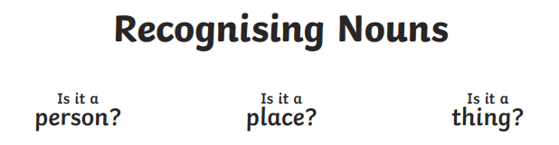

Task 1:

Read the text below and identify the nouns within it.
Remember nouns d escribe a person, a place or a thing.

Alexander was getting ready for school. He brushed his teeth and ate his breakfast. He got his bag ready, put his jacket on and shouted ‘see you later!’ to his mum as he headed out the door and walked to the bus stop.
Alexander met his friends, Simon and Kahmari, at the bus stop and they waited for the bus together. Kahmari and Simon lived quite close to Alexander. Kahmari stayed in a house near Sainsburys, and Simon lived in a flat on Wandsworth. They didn’t wait too long for the bus to come. When the bus came, they gave the bus driver their money and went to find a seat. There were lots of people on the bus - it was very busy!

Alexander’s first class of the day was science. He liked Maths because his teacher, Miss Thorn, was very funny. At lunchtime, Alexander went to the dinner hall to buy his lunch. He bought himself some pasta and an apple, and went to sit beside his friends. After lunch, Alexander, Kahmari and Simon had art and then history. In history, they learned about Martin Luthur King and about Blash history. At home time, Alexander and his friends walked to the bus stop to get the bus home. They were all tired after their busy day!

Your Task
How many nouns did you find?
List them below!

Person | Place | Thing
Alexander  Kahmari  Simon  Martin Luther king  Miss Thorn | School  Wandsworth  Sainsburys  Home  Bus Stop | Science  Maths  History  Teeth  Breakfast  Bag jacket  Lunch  Bus driver

Task 2:
Look around your house and write down as many nouns you can find.

_Mouse, Grandma, Grandad, chair, table, keyboard, sofa, tv, phone, Alexander.

Task 3:
Write Four sentences with noun phrases!

This phone is grey and it has a see through cover.

The brown chair has a white cushion.

The soft and green sofa has a red blanket on it.

This mouse pad is red on one side and on the other side is black_______________________

