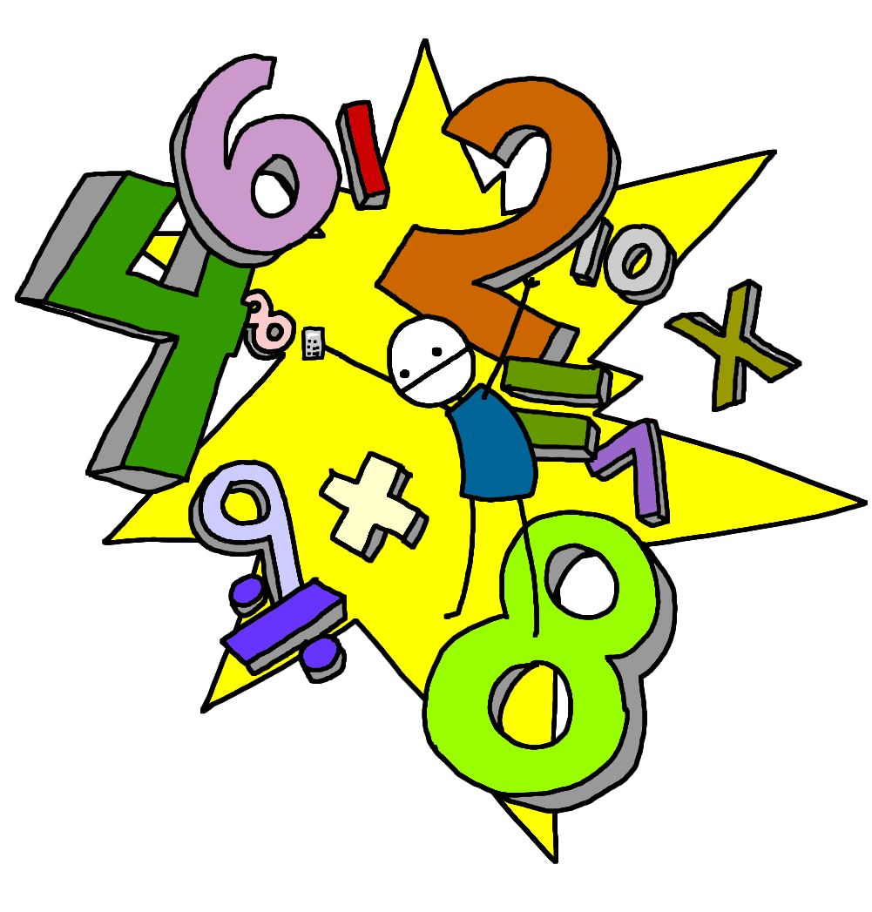
Week beginning 15.6.20
Mental Maths: Adding and subtracting multiples of 10
Work out the answers to the following questions in your head and write your answers.
Remember to double check your answers before handing it in.

24 + 20 =44
38 + 40 =78
26 + 30 =56
63 + 20 =83
45 + 50 =95
27 + 20 =47
14 + 30 =44
29 + 60 =89
46 + 30 =76
46 – 20 =26
24 – 10 =14
63 – 20 =43
58 – 30 =28
85 – 50 =35
62 – 40 =22
81 – 30 =51
53 – 20 =33
74 – 20 =34
34 – 30 =4
6 + 50 =56
48 – 30 =18
28 – 10 =18
2 + 40 =42
7 + 10 =17
13 – 10 =3
8 + 10 =18
47 – 30 =17

