Maths Lesson 2
Number and Place Value-

Click and watch the links below before completing this task.

Recap: let's learn about Numerals!
https://www.youtube.com/watch?v=u6tviKI--is

Recap:Let’s learn how to count using Base 10 blocks!
https://www.youtube.com/watch?v=H3NTWfRvFrg

Task 1:
Write the value of the number represented in the place value chart.

Thousands | Hundreds | Tens | Ones | Answer
 |  | 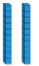 |  | Numeral  196______  Words  One hundred and ninety six
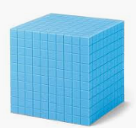 |  |  |  | Numeral  1344______  Words  One thousand three hundred and forty four _______
Challenge |  |  |  | Numeral  2531______  Words  Two thousand 5 hundred and thirty one

Task 2:

a) Use the blocks below to complete this place value chart, so that it shows 435.

Hundreds | Tens | Ones
Click on the blocks and drag them into the correct box (or you can copy the block and paste it in the correct box)

b) Now, make your own place value chart using the blocks below or you can use numbers if you prefer.

Thousands | Hundreds | Tens | Ones | Answer
 |  |  |  | 1111
 |  |  |  | 2222
 |  |  |  | 3333
Click on the blocks and drag them into the correct box (or you can copy the image and paste it in the box)

Task 3:
Chris has used Base 10 blocks to represent the number 420. He has covered some of them up.

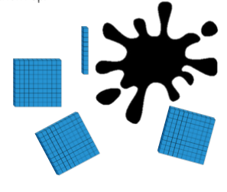
Work out the amount he has covered? 110_____

Write the amount in words- one hundred and ten____________

