Outside (Outdoor) Activity
Note to Parents: Some parts of this task will need to be completed on a separate sheet.
Please take a picture and attach to this work before ‘hand in’.

Tree Observation
WALT- look closely at plants and trees and record what I see.

Task 1: Task 2
Tree Diagram: Draw a picture of an interesting tree and label the main parts.  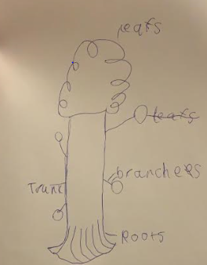 | Leaf Observational Drawing: Find a leaf from the tree you have drawn. Look at it carefully (if possible, with a magnifying glass) and draw  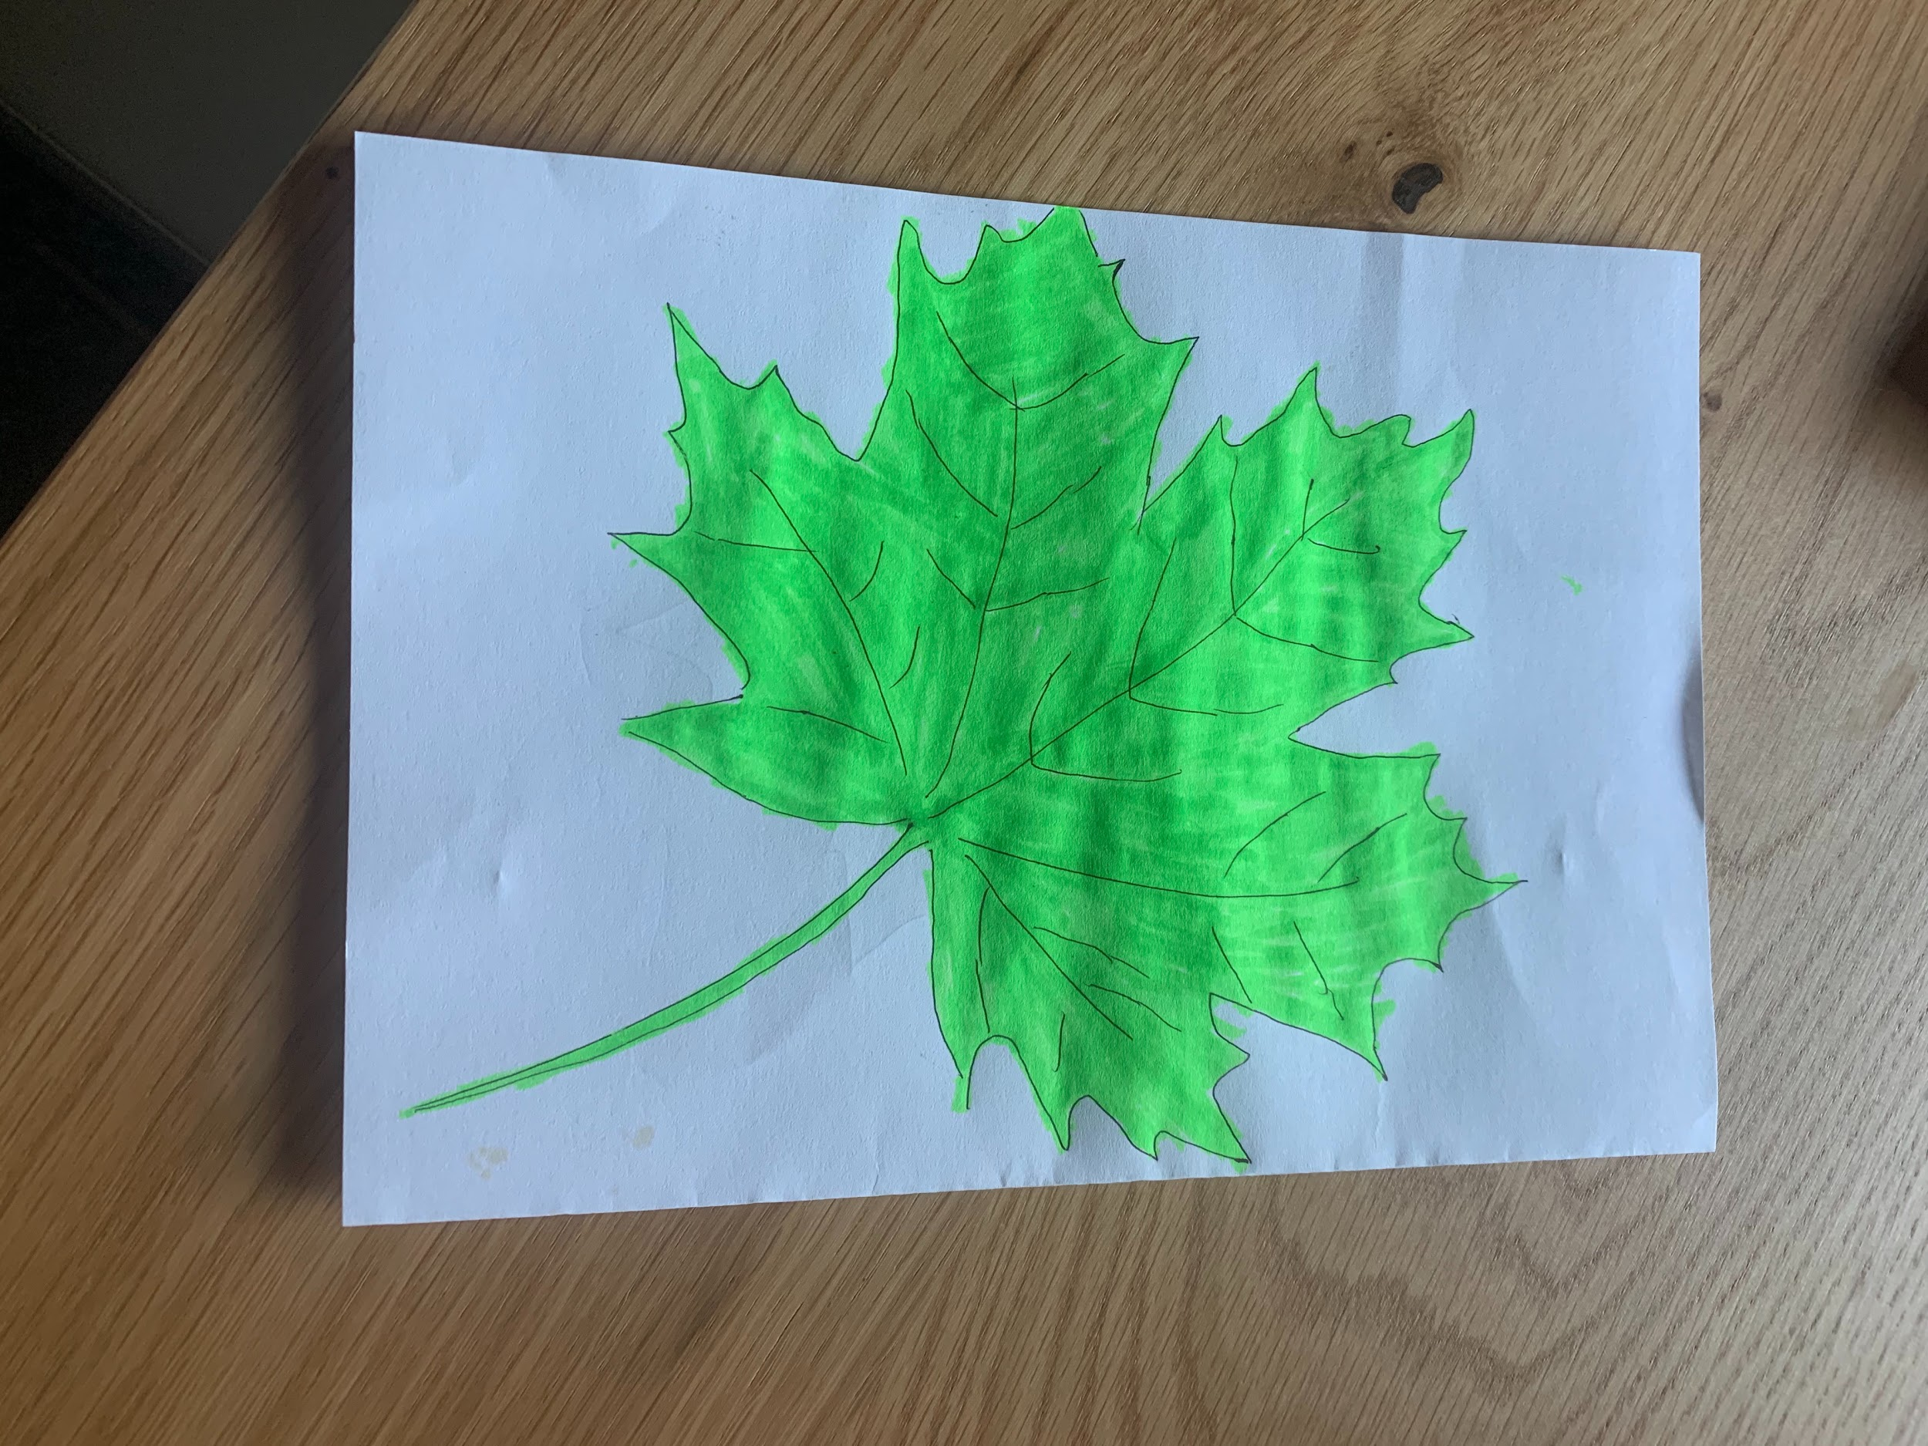what you see.

Task 3:
Measurement:

Leaf

- Estimate (guess) the length of the leaf _12____ cm

Measure the leaf with a ruler.

- The leaf is __20_____ cm long.

- The leaf is ___12____ cm wide.

- Write a description of the leaf. The leaf has pointy edges and it is bright green.

Measurement:

Tree

- Measure around your tree with a tape measure: ___40___ cm

- Estimate (guess) the height of the tree _20____ m

- Write a description of the tree. It has a brown trunk and green leaves.

