Maths 10.6.20
Number and Place Value

Click and watch the links below before completing this task.

Recap: let's learn about Place Value:
https://www.youtube.com/watch?v=sepBmoXqYfc

Task 1:

1a) Which numbers should replace the two empty circles?

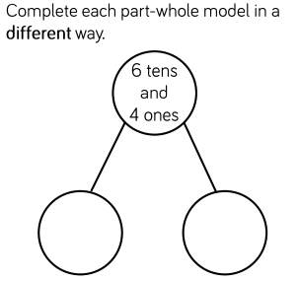

Write your answers here: _60____ and __4____

1b) Which numbers should replace the question marks?

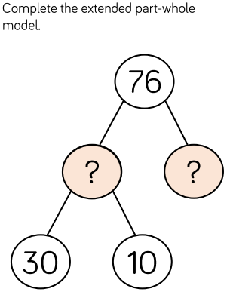

Write your answers here: 40_____ and 36 _____

Task 2:

Write these number words in numerals.

Sixty Eight _68___________

Seventy Nine _79_______

One Hundred and Twenty Two 122_______

Three hundred and Seventy Six ___376_____

Five hundred and fifty One 551________

Seven Hundred and Forty ____640________

Six Hundred and Thirty Four _634________

Nine hundred and Ninety Nine 999__________

Task 3:
Use < > or = to make these statements correct.

54 __>___ 42

76 __>___ 65

88 __=___ 88

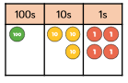 ____=_____

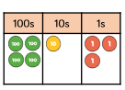 ____>_____

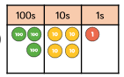 __>___ ___<____

Task 4:

1a)
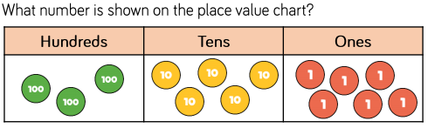

_356_______________

1b) If one more ten is added to the place value chart, what number would it show? _366_____

1c) Joela says the number in the place value chart is greater than 400.

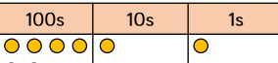

Is she correct? _yes_____

Explain your answer: she is right because she has 411 and not just 400
______

1d) If one more hundred is added to the place value chart, what number would it show? 511______

Task 5:

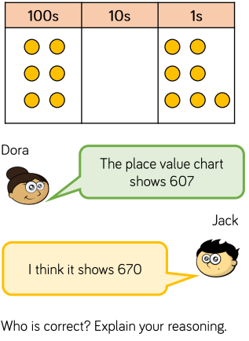
Write your answer here: _Dora is right because they is not 7 tens like Jack thinks.________

