Maths 9.6.20
Number and Place Value

Click and watch the links below before completing this task.

Recap: let's learn about Place Value:
https://www.youtube.com/watch?v=sepBmoXqYfc

Task 1:

a) What is place value? ___is the basis of our number system__________

b) Identify hundred, tens and ones in the following numbers.

19
Ones: _9_____
Tens: _1___

65
Ones:5 ______
Tens: 6_____

89
Ones:9 ______
Tens: 8______

125
One: _5_____
Tens _2_____
Hundreds: 1_____

241
One: 1______
Tens _4_____
Hundreds: 1_____

380
One: _0_____
Tens _8___
Hundreds: _3____

978
One: 8______
Tens 7______
Hundreds: _9____

Task 2:

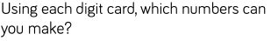
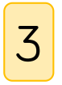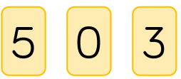
Hundreds (100s) | Tens (10s) | Ones (1s)
5  3 | 3  3 | 0  5

What is the largest number you’ve made? __530_______

What is the smallest number you’ve made? _335_______

Why can’t zero (0) be used as a tens number? Because it is not in the tens family________

Task 3:

Let's learn about Numerals!
https://www.youtube.com/watch?v=u6tviKI--is

Match the numerals with the words below.

Numerals:

54 __fifty four____________

99 _ninety nine_____________

88 eighty nine______________

69 _sixty nine_____________

156 _one hundred and fifty six_____________

203 two hundred and three______________

472 _Four hundred and seventy two_____________

866 eight hundred and sixty six______________

940 nine hundred and fourty______________

Words:

Four Hundred and Seventy Two, Sixty nine, Ninety Nine,

Fifty Four, One Hundred and Fifty Six, Eight hundred and Sixty Six,

Sixty Nine, Nine Hundred and Forty, Eighty eight

Task 4:
a)
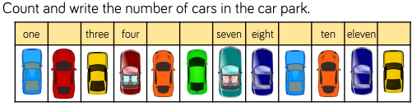

There are _12_____ in the car park.

b)
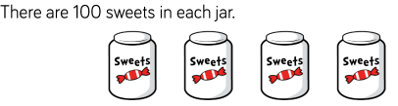

How many sweets are there altogether?
Write your answer in numerals and words.

Numeral: 400__________

Words: _four hundred____________

What strategies did you use? counted_________

Task 4:

Complete the number track.

a)

200 | 300 | 400 | 500 | 600 | 700 | 800 | 900 | 1000

b)

800 | 700 | 600 | 500 | 400 | 300 | 200 | 100

