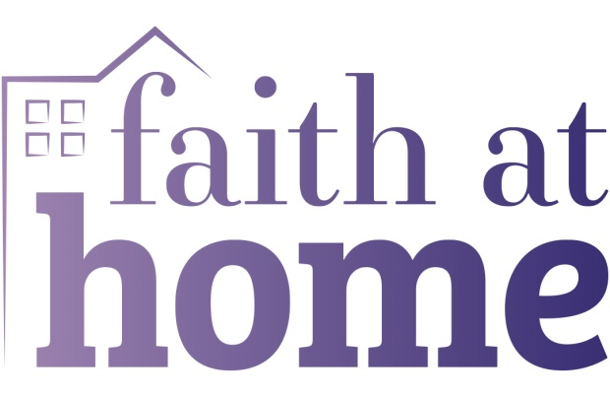
St Anne’s Primary School RE at home- Summer term

Week 5: (from Monday 15th June)
WEEK 5 THEME: HUMILITY

Key message:
We live in a world where some people say: “look at me, look at me”, chasing after fame and wanting to be noticed. Yet the real heroes (as we have seen over the last few weeks) are the everyday people who care and think of others. Many Christians across the world believe that Jesus is a ‘Servant King’ – one who both showcased and valued humility, calling others to follow his example, too. Being humble means having a realistic picture of ourselves – to be mindful of the times we do amazing things (wow!), the times we fail (ow!) - and seeks to build others up, rather than looking for fame or recognition.
In the Bible, James 4:10, it says ‘humble yourselves before the Lord, and he will lift you up.’
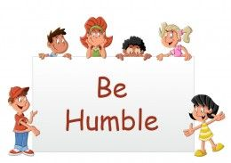

Reflective starter
‘Fix You/ Bridge Over Troubled Water’ sung by the NHS Choir – two beautiful songs about thinking of others, interwoven and sung by everyday heroes:
https://www.youtube.com/watch?v=T8qHXlShfUQ

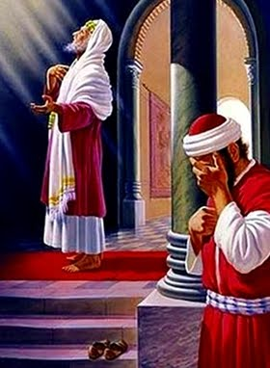
KS2
The Parable of the Pharisee and the Tax Collector (Luke 18: 9-14)
‘For those who make themselves great will be humbled, and those who humble themselves will be made great’ (Luke 18: 14)
In today’s Bible story, Jesus speaks about two kinds of people.
Now watch the story one of these videos – or both, as they are both good in different ways.
https://www.youtube.com/watch?v=Ufe6zouTq8g
Or
https://www.youtube.com/watch?v=kLCSVjHKQjk
Did you notice…?
What the Pharisee does to show how ‘good’ he thinks he is?
What the tax-collector does to show that he knows he is not perfect – that he has done things that are wrong?
Who Jesus says is ‘right with God’ that day? How do you think the tax collector would feel on hearing this? What about the Pharisee?
The Pharisee liked to draw attention to himself. ‘Look at me! Look how amazing I am! Look how I am so much better than others around me!’ In order to build himself up, he put others down. This is the opposite of what humility is. Humility, or being humble, is about putting others first and knowing that you are not perfect.
In this Bible story, Jesus mentioned that it was the tax collector that God was most pleased with… the tax collector who would be made great.

TASK 1:
Write an acrostic prayer about Humility. This could mention what humility is and isn’t, perhaps including some examples. Read it to yourself – or to someone in your bubble at school or a family member at home..

TASK 2:
Can you find a shoe in your home or at school – one that’s been well-used, perhaps a bit smelly?
Hold it and ask yourself, how has it been damaged or scuffed as it’s been used? What it’s made of, who might have made it?
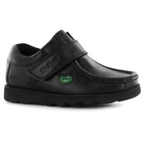
Today we are going to use this shoe, and others, to learn more about humility – being humble. Humility is a difficult word to understand. But it’s a wonderful quality! If you have humility you can really listen to people, and you can see the good in everyone – and you can accept that you are not perfect!
Have you had moments in your life where you have boasted, bragged or put others down to make yourself look good? Have you had times when you’ve been humble, looking at the wonder of others rather than the wonder of ourselves?
You can draw your shoe and write around the outside some nice phrases you could use to build someone up and make them feel good.
At home- Create a tower of shoes using those you are allowed to in your home. As you do so, think… …about how you could build others up this week …how others in your life help to build you up and support you …how we are not perfect – everyone makes mistakes and can accidentally knock people down. If we say sorry, we can help to rebuild relationships.

