 **Pine Class Home learning Week 13 (Wk b 15th June 2020)**

|  |  |
| --- | --- |
| **Reading:**  See the source image**1 per day** | Please complete the Year 3 and year 4 Daily reading lessons on The Oak National Academy. You will practise your reading comprehension skills this week.  <https://www.thenational.academy/online-classroom/year-3#schedule>  <https://www.thenational.academy/online-classroom/year-4#schedule>  Also, Read your home reading book or a book from the Oxford Owl website. Try to read for at least 5 mins every day.   * Explore new vocabulary you find when reading. What are the origins of this word? Can it be modified? Can you find any synonyms or antonyms for your new word? Record the new words you find in your reading record. * Remember to read every day and record a comment in your reading journal. |
| **Writing:**  **1 per day** | **Weekly writing task: Visual literacy- ‘For the birds’**  https://files.edshed.com/production/images/curriculum_resources/507/image-415632..jpg   1. Watch the video on the Pine Class blog, about how a bird deals with bullying   This week you will be researching bullying and then will be planning and writing a persuasive letter to the bullies urging them to stop bullying the big bird and to think about their behaviour.  Use the activity sheets at the end of this document.  Complete the SPA activities and then complete the longer writing tasks using your writer’s tools. |
| **Maths:**  See the source image**1**  **per day** | Please complete the Year 3 and year 4 White rose maths lessons.  On the **blog** I have included this week’s video links for each lesson. Just click on the link and it will take you straight to the lesson video.  I have also uploaded each lesson task as well as the answers. Self-mark your work and edit any corrections.  Year 3 -This week you will be ordering, adding and subtracting fractions.    Year 4- This week you will be comparing, ordering and rounding decimals.   * Keep playing Sumdog, hit the button and maths frame- Use these games to practise your times tables and key number facts. Try to play these for at least 5 mins every day. * Continue to practise telling the time at home this week.   <https://mathsframe.co.uk/en/resources/resource/116/telling-the-time> |
| See the source image**Science:** | Pizza Clip Art Pizza Clipart Photo Niceclipart - Pizza Clipart ...  Have a go at this cooking challenge:    Can you use your measuring skills to follow  the recipe and cook an awesome pizza?  What toppings will you choose?  Can you take some pictures of the process?  Complete the recipe card and write down  your method for someone else to follow.. |
| **P4C- Philosophy for children- Talking time**  See the source image | Talking points   * How does the person in each job help other people? * Which is the most important job? Why? * Should some of them be paid more than others?   Activity:   * Talk through the discussion points above * Place jobs in order on the line below and discuss why you think that. * See if you can agree on a common view with your family |
| See the source image**RE:** | This week our RE theme is ‘Humility’.  30 Top Bible Verses About Pride - Encouraging ScriptureYou will be thinking about The Parable of the Pharisee and the Tax Collector (Luke 18: 9-14) where Jesus speaks about two kinds of people.  Jesus speaks about two kinds of people.    The RE tasks can be access via the blog. |
| **PE: (Choose one)**  See the source image | Complete the Joe wicks daily workout  Complete a go noodle/ Just dance exercise video  Make up your own dance/  Design and complete an assault course. |
| **Art** | **How to draw**  This week you will be practising your drawing skills using our bumper pack of ‘how to draw’. Follow the step by step guides to learn how to draw a range of things including a car, penguin. Access the activity on the **blog** |
| **Coding**  Image result for Coding Clip Art | Complete some online coding lessons using Espresso coding  <https://central.espresso.co.uk/espresso/coding/lessons.html#/coding/units>  Turtle academy  <https://turtleacademy.com/lessons/1?lang=en_US&lang=en_US>  Scratch  <https://scratch.mit.edu/projects/editor/?tutorial=getStarted> |
| **PHSE**  Image result for phse | This week we are going to be thinking about our Family history and will be creating a family tree.  Look at the Family tree power point and then complete the family tree worksheet.  This will be a lovely opportunity to talk to your family about their parents and grandparents.  **The power point and worksheets can be access via the blog**  Family tree generation genealogical tree with Vector Image   * You can use the worksheet or if you prefer you can   record and present your family tree in a different  way, using photographs, as a poster or on the computer. |
| **Music** | **Learn a new song ‘As One’**  **Our song this week is all about writing!**  Listen to the song on the blog and then complete the activities.  <https://youtu.be/vE9T9knqG2A> |

English:

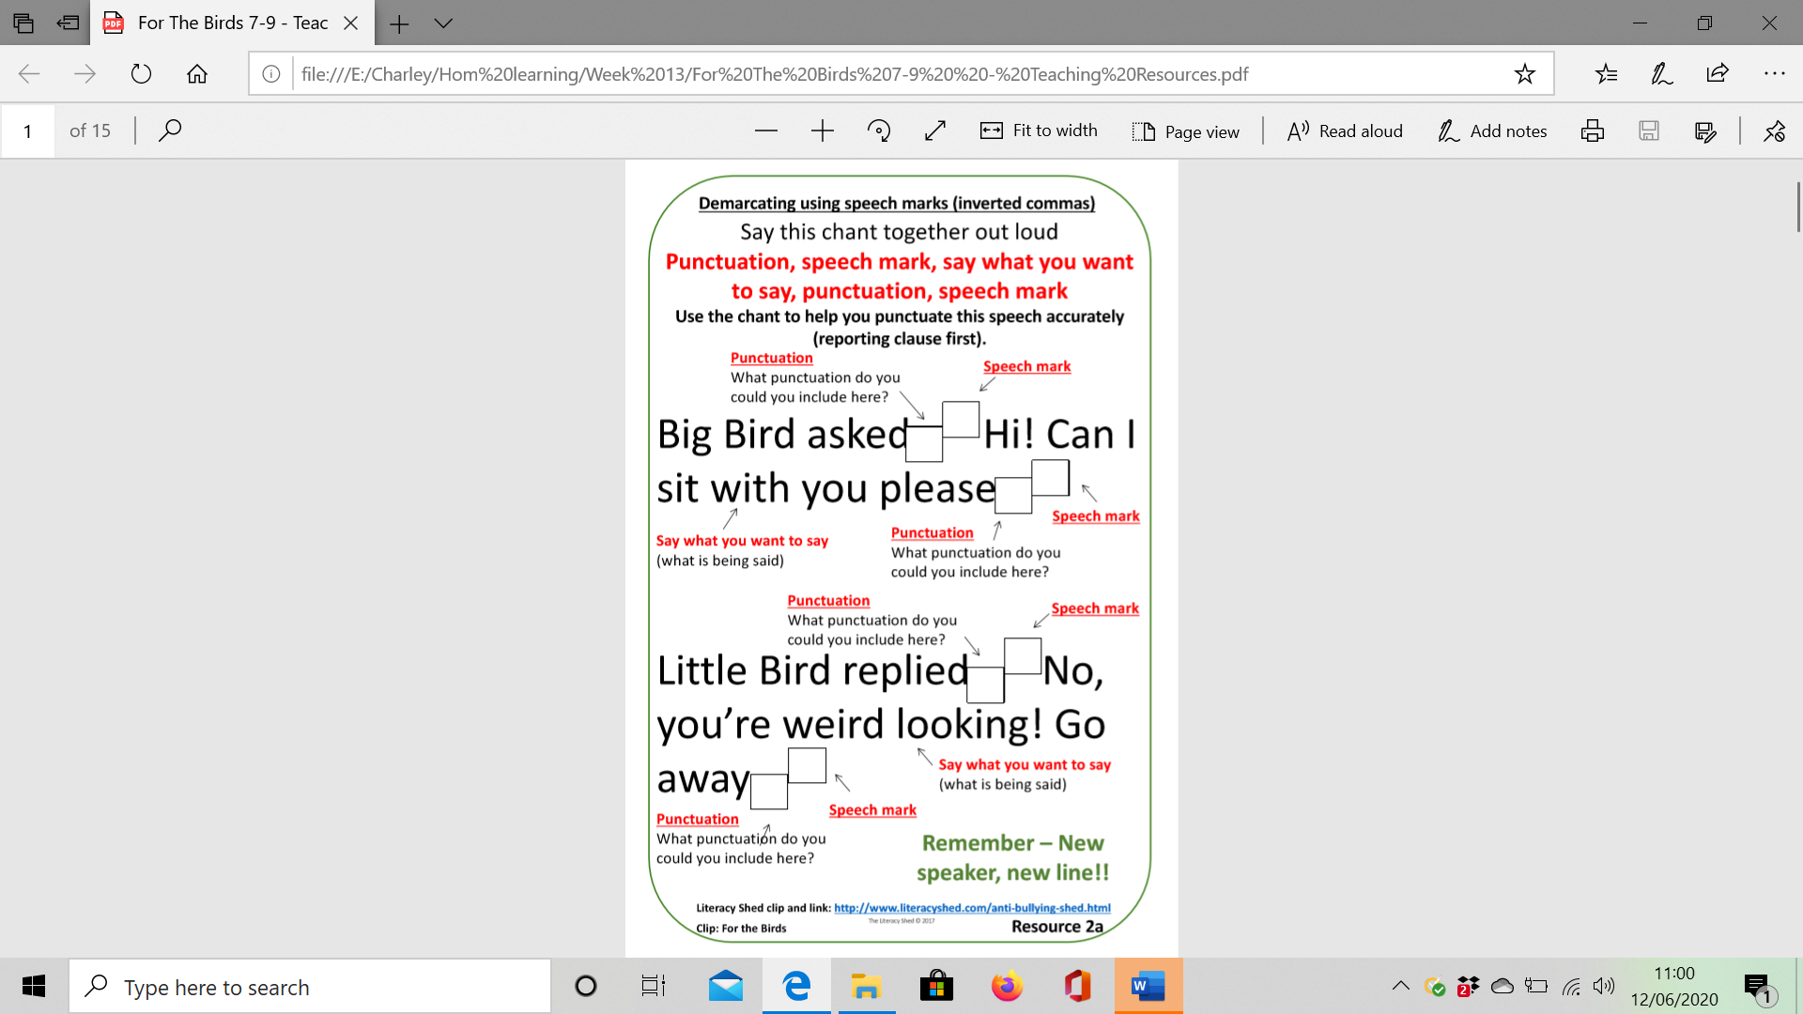Monday: Inverted commas <https://www.bbc.co.uk/bitesize/topics/zvwwxnb/articles/ztcp97h>

Tuesday: Direct speech - A **reporting clause** after the direct speech tells the reader who is speaking.

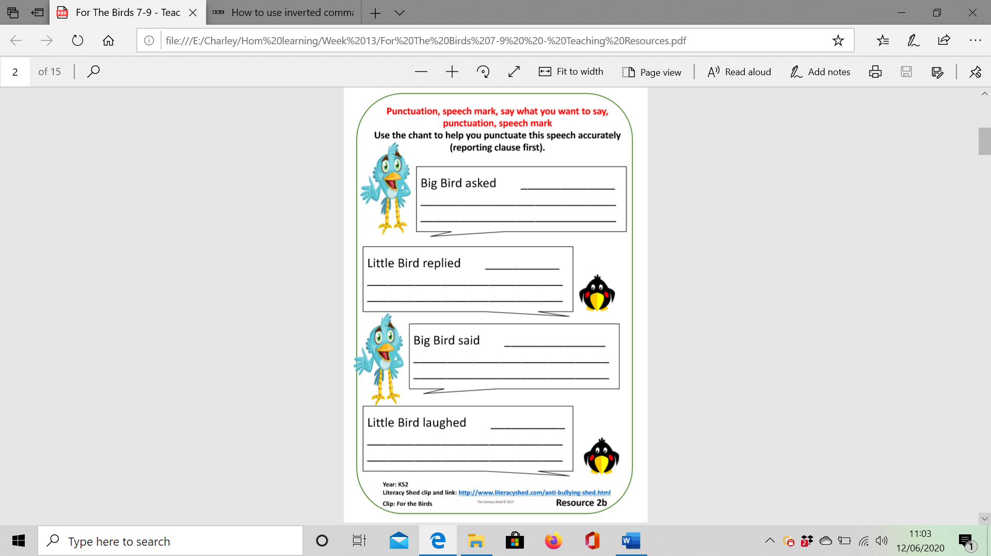

Challenge:

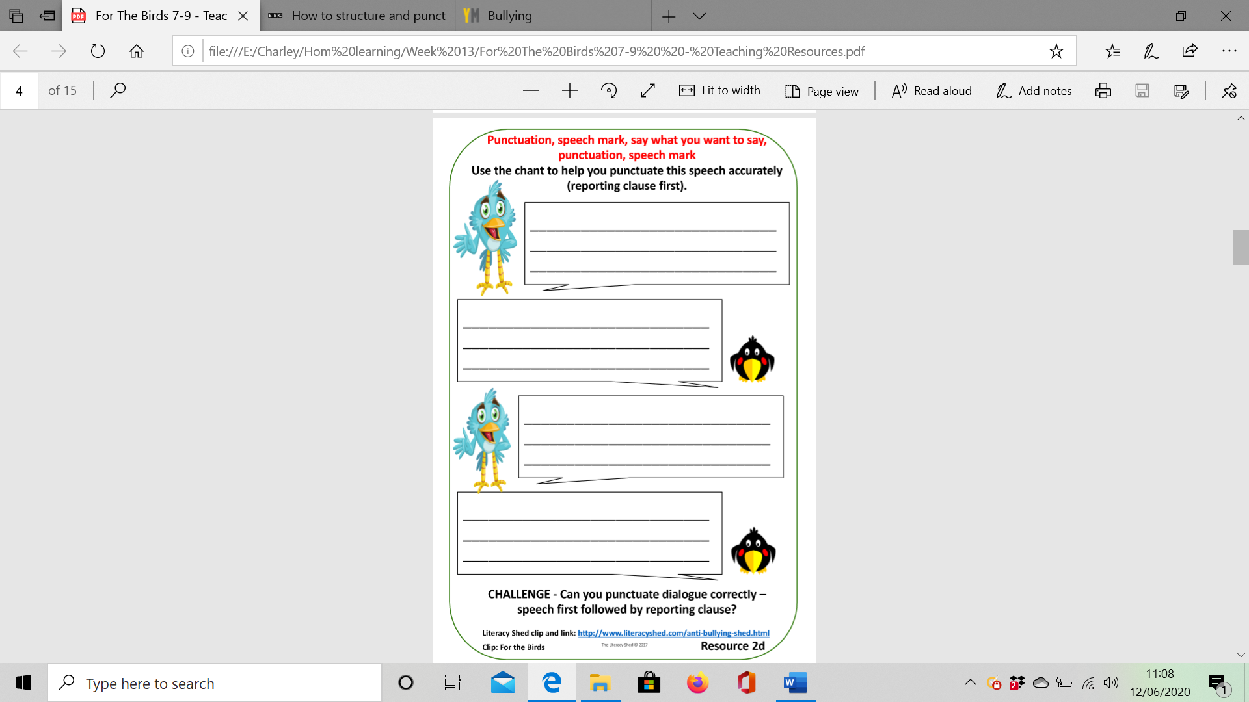

Wednesday: Researching skills – You can use books, magazines or the internet to research your subject

<https://www.nspcc.org.uk/what-is-child-abuse/types-of-abuse/bullying-and-cyberbullying/>

<https://youngminds.org.uk/find-help/feelings-and-symptoms/bullying/>

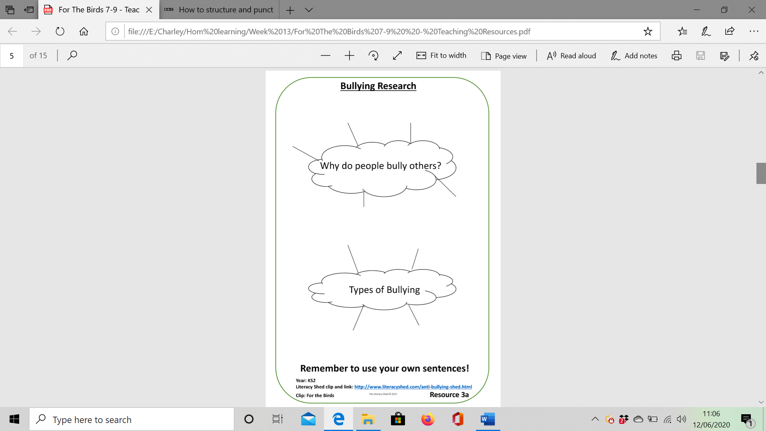

Thursday: Planning your own Persuasive letter

Now you are going to write a letter to the bullies urging them to stop bullying the big bird and to think about their behaviour. You must persuade them that it’s the wrong thing to do. In order to persuade them, your argument must be string. You will need to start by introducing a main point and then back this up with more points (or reasons) to make it stronger.

EG. Your main point: The bird looks different

Back up points: If everybody looked the same the world would be boring

Nobody can help the way they look

Never judge a book by it’s cover.

Use the plan and your research to help you.

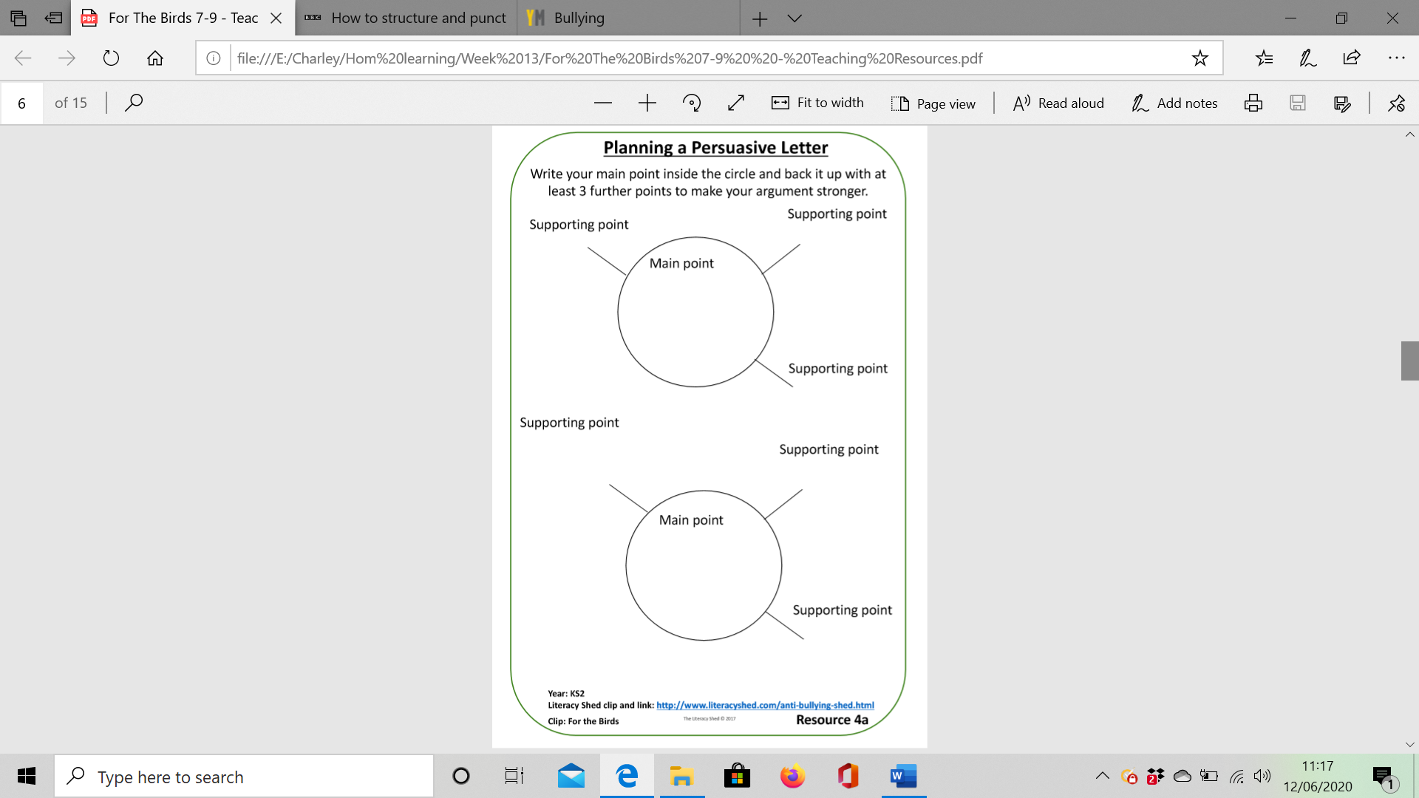

Friday: Persuasive letter writing

Now write your letter based on your plan.

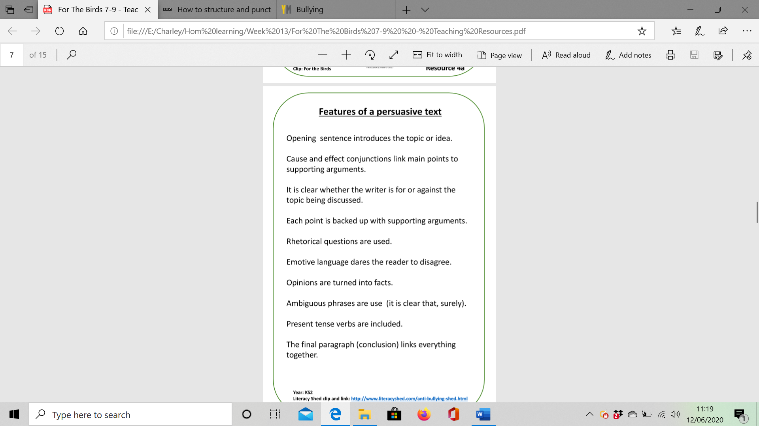Use the writer’s tools checklist, the word bank and conjunctions to help you.

Remember to read and check to make sure that your writing makes sense.

