
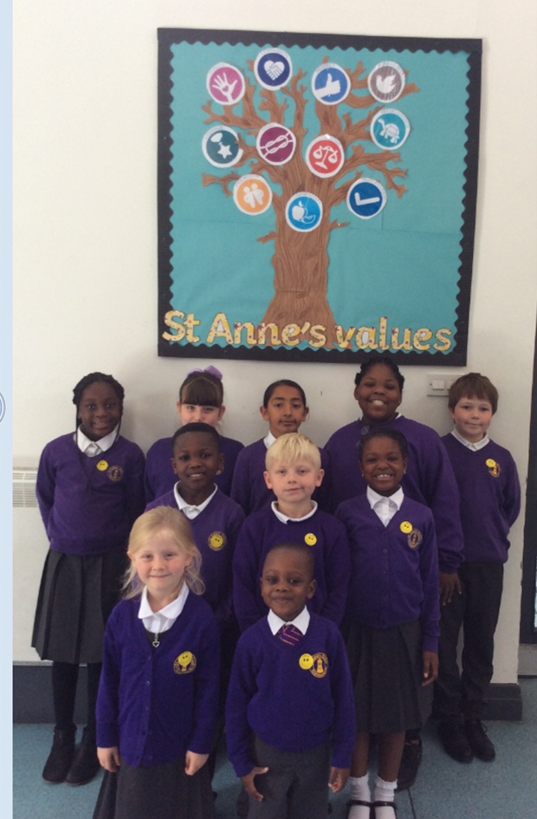
St Anne’s Faith Group 2019/2020

Olive- Micah & Emily
Willow- Harry & Rithanna
Pine- Megan & Simeon
Cedar- Olivia & Celina
Elm- Joe & Zamira

