Again we have had another very busy half term! The children are working hard and making lots of links in their learning. To help us learn about the ‘People Who Help Us’, we have had important visitors into our Reception class; including the Community Police Officers and The Fire Brigade. The Police Officers were very friendly and reminded us about their special number – 999, if we need help. The fire fighters showed us lots of different equipment and lets us squirt jets of water high into the air and all over the teacher’s cars! We really enjoyed sitting in the fire engine.

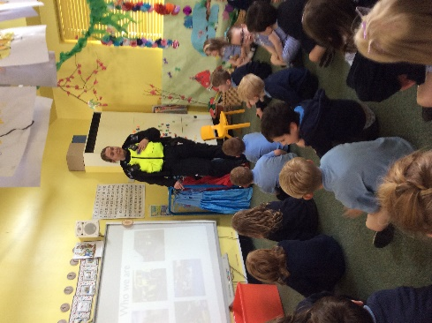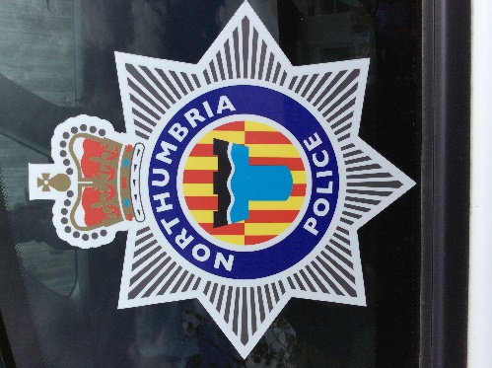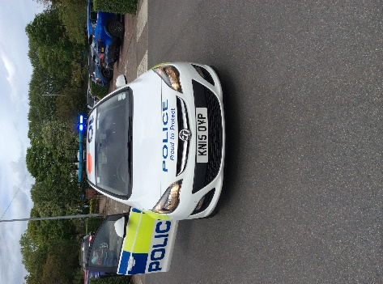
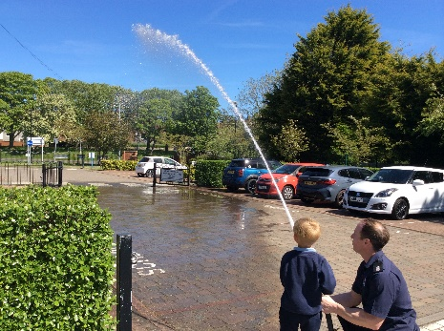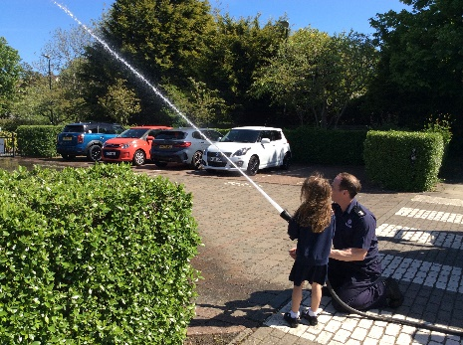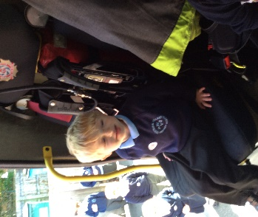

We have worked hard to learn about the Queen as a child and prepare for our Platinum Jubilee celebrations. To add to our tea party the children made cakes and ‘jam pennies’, we developed our science knowledge of changing materials and had a treat at the same time! We also developed our math’s skills weighing the ingredients and understanding ‘more’ and ‘less’ in quantities.

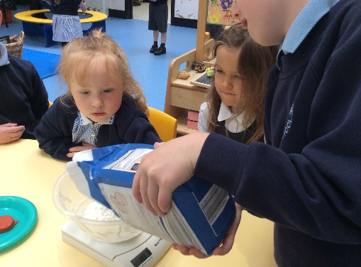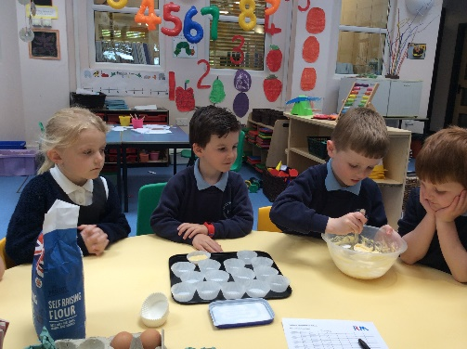

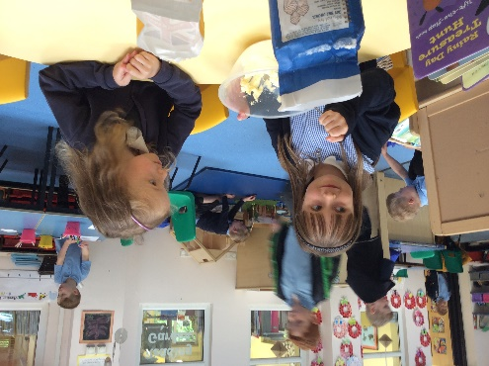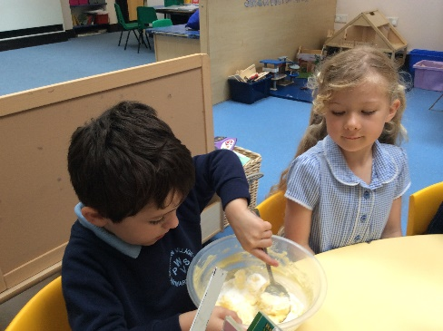

In Maths the children are learning to count in different steps and we really enjoyed making our ‘two pattern’ crowns. A little bit of work at home over the half term break about sharing would be really helpful. E.g. share out the cutlery at mealtimes, share out cards in a game, and share pieces of a pizza.
We are going to come onto ‘sharing’ after our half term break.

In Literacy we have been writing stories with a beginning, a middle and an end. We have loved reading: ‘Owl Babies’, ‘The three little Pigs’, as well as lots of other stories. We have also looked at non- fiction texts and photographs of Queen Elizabeth II.

It would really help your child if you could practise their new sounds and tricky words at home.
Sounds: ng, nk, sh, th, ee, ay, igh, ow (as in blow the snow), oo (as in ‘poo at the zoo), and oo (as in look at a book), please remember we say two letters together are ‘special friends’ and three letters together e.g. ‘igh’ is a ‘greedy grapheme’.
Words: no, so, go, you, he, me, she, be, we.

We are great artists in Reception and we have really enjoyed painting and collage work. Our Sunflowers are very colourful and our Portraits of the Queen for our bunting display are fabulous. We really enjoyed getting the glitter out!

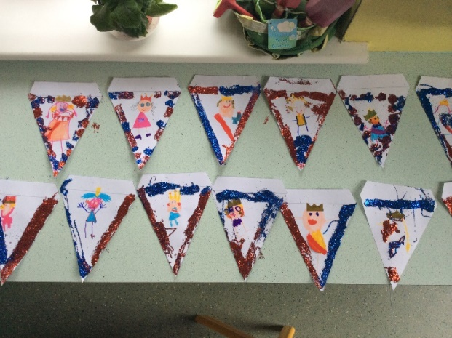

Looking forward to Summer Term 2. Other work in writing will include simple poetry and writing about our Summer activities. In maths we will continue to build on previous work to improve our knowledge and manipulation of numbers to 10 and 20. We will also introduce sharing, and consolidate our work on halving and doubling.

