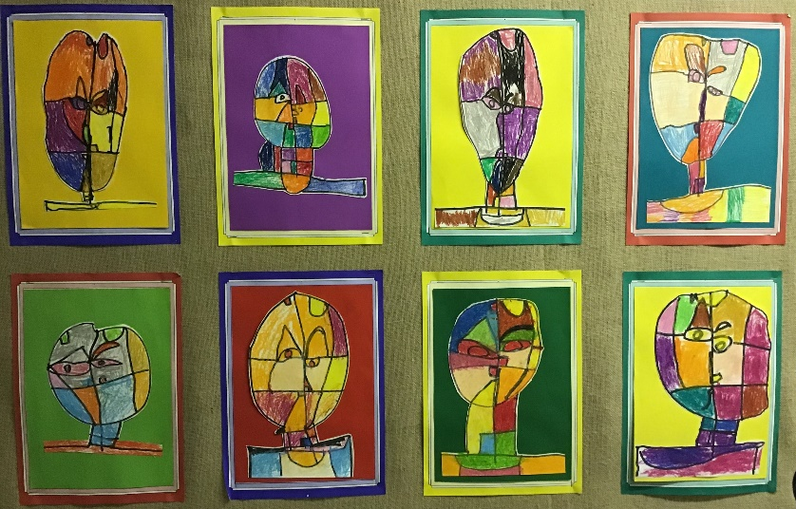
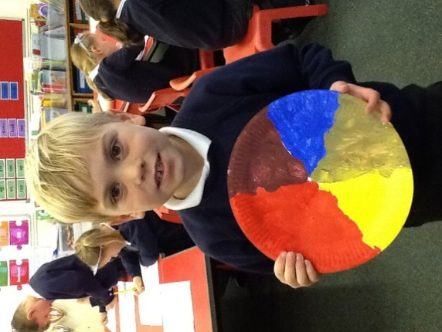
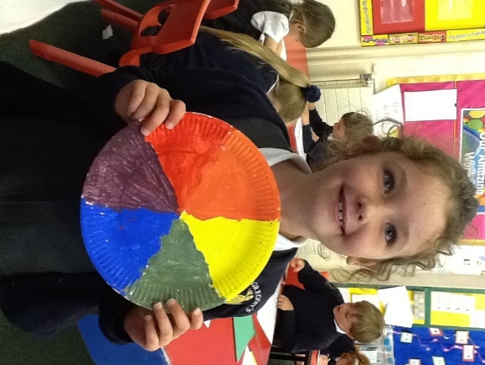
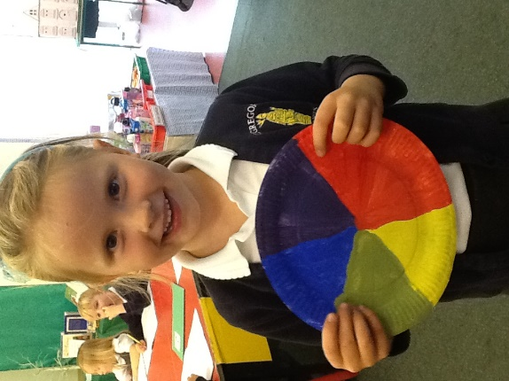
In Year 1 we have been exploring colour mixing. We found out what a primary colour was, and we used blue, red, and yellow to make our own secondary colours: orange, green and purple. We created our own colour wheels using the colours we mixed.
We decided that we wanted to use our knowledge of colour and portraits to create a piece of artwork for our display. We learnt all about abstract art and did some research into different artists who have created abstract portraits. In the end, we decided to create an abstract portrait inspired by Paul Klee. We were all very proud of the results!
