Year 5
Autumn Term 2020
Despite the worst 2020 could hurl at us, Year 5 have begun this academic year with enthusiasm. We began our ‘recovery curriculum’ with the book Here We Are, by Oliver Jeffers. This eased us all back into school life, with a focus on mental health and wellbeing. We wrote some beautiful lyrics to the song Wonderful World, and welcomed in Mrs MacSheffrey from Tranquil Treehouse, to run a 6 week mindfulness course.
We are now fully into the swing of our Autumn Term topics. We really enjoy studying rock music on a Wednesday and some of us have started brass lessons with Mr Storey from South Tyneside. Mr Richardson is helping us rehearse some Christmas songs which we are going to perform in our class bubble for the South Shields Civic Carol Service. This will be online and is due to be released at the beginning of December.
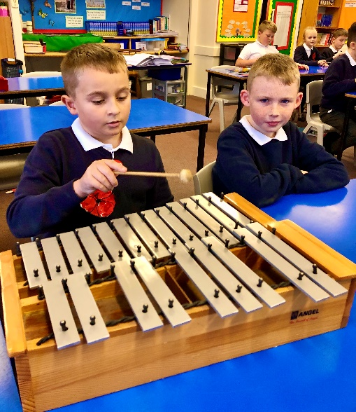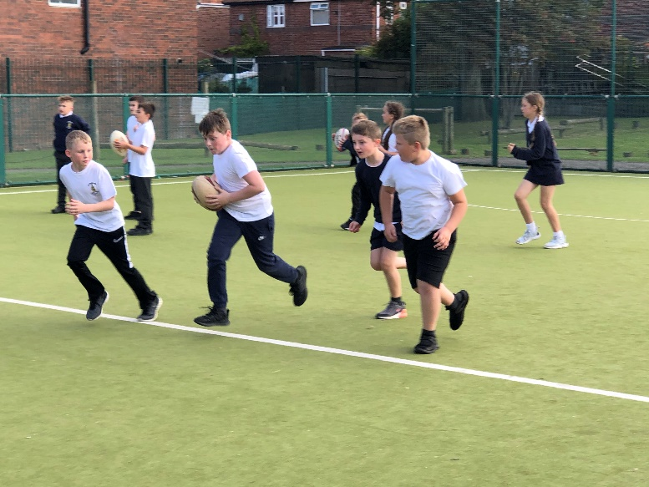
We have been getting muddy in PE and learning some rugby. We were getting quite good at tag rugby before half term.
In English lessons we have read the book Kensuke’s Kingdom by Michael Morpurgo. We enjoyed learning different words from the text and putting them into sentences of our own.
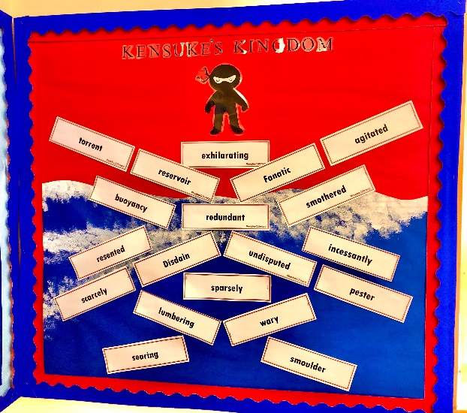
In art we have designed our own Anglo Saxon illuminated letter which has taken pride of place on the front of our History book. We looked at the first story from the Anglo Saxon epic poem Beowulf, which told us a lot about Anglo Saxon life and beliefs. We look forward to our Science lessons with Mrs Benson on Thursdays and Computing with Mr Faircloth on Fridays.
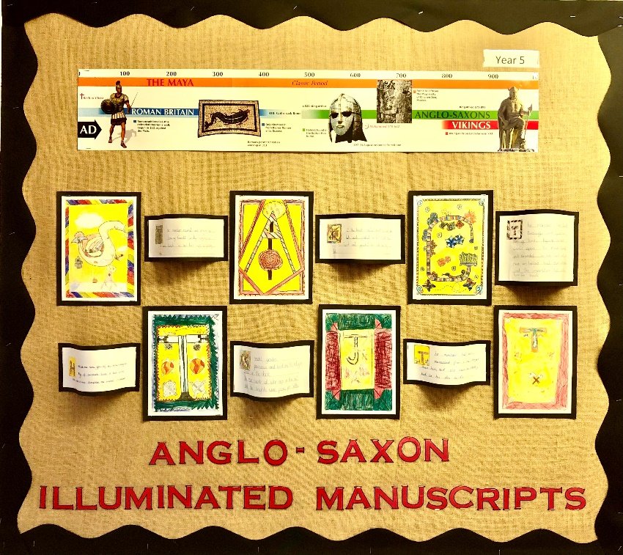
One of the highlights of last half term was when we all took part in creating an electronic version of the Harvest Assembly. We recorded our spoken parts over the top of our presentation and each bubble visited the hall at different times to watch it.
