Parent Carer Survey
Dear Parent/Carer,
We are delighted to inform you that your school is participating in the Partnership for Inclusion of Neurodiversity in Schools (PINS) programme. The programme is a collaboration between participating schools, the local authority, the NHS, and the Parent Carer Forum for your area, with the aim of improving support for children with additional needs.
A key component of this project is the voice of parent carers. We invite you to complete a short online survey that will give us some invaluable feedback and help to shape the priorities of the programme for your school.
The link for the Microsoft Forms survey, that you should be able to complete using any Internet browser, is: https://forms.office.com/e/e6404RRSU3 , or alternatively, you can scan the following QR code:
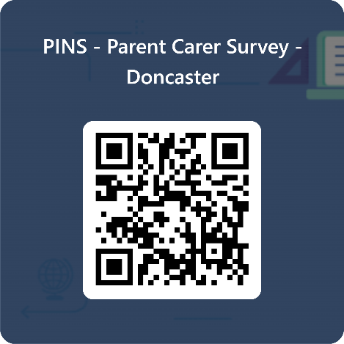
We will also be inviting you to participate in some Parent Carer Participation meetings in the school, with the aim of:
- Ensuring parent carer voices are heard by the school.
- Improving cooperation and collaboration between schools and parent carers.
- Bringing together parent carers with shared experiences for peer support.
Information and invitations to these meetings will be shared with you in due course.
If you have any queries, please contact your school’s SENDCo or feel free to contact me directly.
We look forward to receiving your feedback and your future participation.

Kind regards,
Giovanni Pezone
Giovanni Pezone
Parent Carer Representative and PINS Coordinator
Doncaster Parents Voice
giovanni@doncastercarers.org.uk

