Step 14  This week we have been learning… | 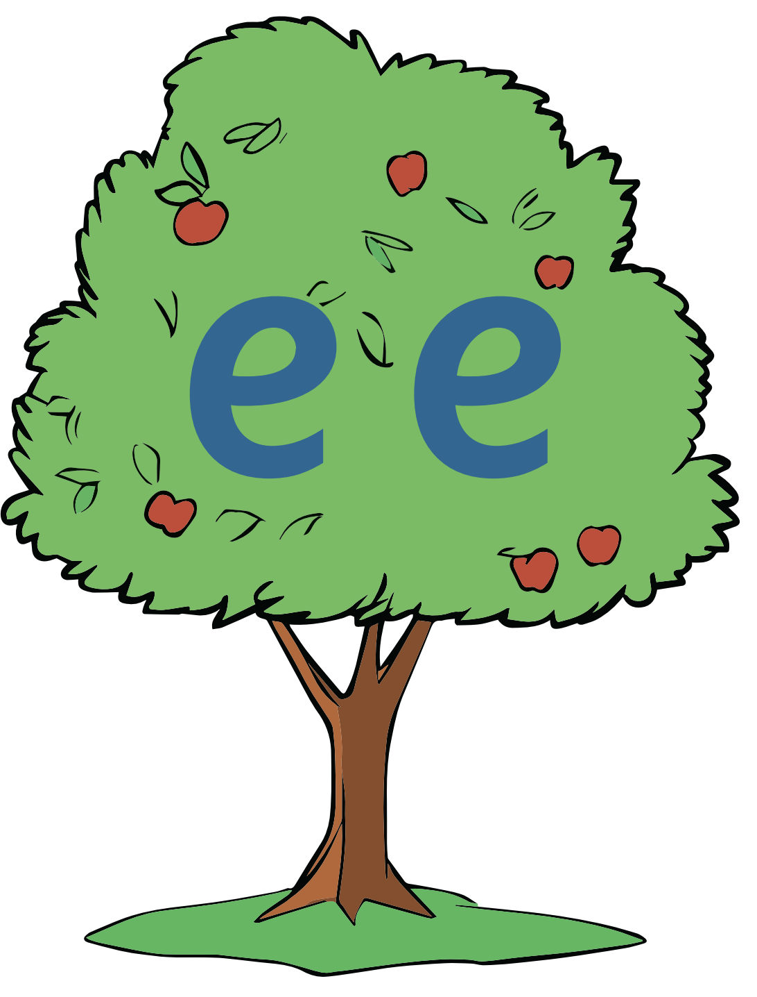  See the tree |  |  |  |  |  |  | Can you read the words and sentences?  Why not challenge yourself to sound out and write the words without looking at them?
Green Words |  |  |  |  |  | Red Words
green  sleeps  cheek  sheep  creek  sleeping |  |  |  |  |  | my  by  so  do  you
“Well, let me see. Yes, I need my brush and the green paint.”

